Police and Augmented Reality Technology
Student’s Name
Institution Affiliation

Police and Augmented Reality Technology
Augmented reality (AR) is a technology that works incorporate digital information with user’s present location enhancing the user’s real-world experience. Augmented reality has significant applications in industries, including medical, travel, gaming, and law enforcement. The use of AR in law enforcement can bring fantastic innovation and creativity that will be of great advantages to cops and also in protecting citizens of a given country from legal authorities. With augmented reality, the police and magistrates can monitor criminal actions efficiently by use of Google glasses (Orlosky, Kiyokawa & Takemura, 2017). Augmented reality will make patrolling more streamlined opening a new avenue of potential for academy training methods. For the augmented reality to work, it requires high technology network so that it can meet the expectations. This research paper seeks to find out the roles of technology in policing unit and the importance of augmented reality in streamlining the law enforcement system with application of 5G network.
5G network is the fifth generation of mobile communication which succeeds 4G. 5G performance targets high data rate transfer, cost reduction, energy saving, and massive device connectivity. 5G with its data transfer speed will have a significant impact on people’s perception of information and will help people to maximize their creativity and innovations. Full innovation and creativity are all that is required in developing and sustaining augmented reality. Fifth generation network will help the law enforcers to transmit more data per unit time at a very high and stable speed making people’s actions and their changes in environments be noticed instantaneously.
The law entrusts the police forces with the responsibility of maintaining law and order among citizens. They are supposed to ensure that the citizens are safe without disrupting their daily lives. The police forces find it difficult to maintain the balance between being vigilant and at the same time being friendly to the society (Lemley & Volokh, 2017). Due to such challenges, technologies are being developed to help the law enforcement bodies to be able to perform their duties without one on one interaction with the society. Many technologies have been developed while some of them support the police unit in preventing and fighting crime in the society.
According to Tim Cook, the head of Apple, it was not possible to develop AR-glasses because the technology by then could not support the idea. He argued that a new quality of the display with a full field of overview was required. Smartphones have been developed which uses the fifth network and have achieved the optimal balance between the convenience, functionality, and appearance. 5G will be needed to be used because of its stability of communications and uniformity of the coverage. Stable communication and uniformity coverage prevents disruption while working with the applications.
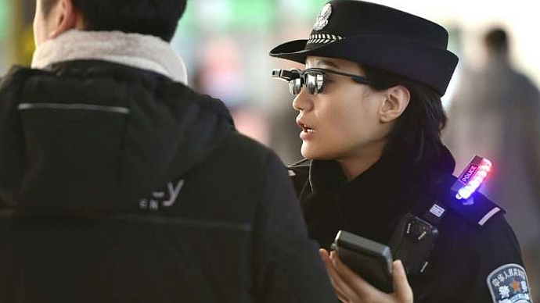
Google glass, the successful augmented reality wearable, is already becoming a favorite new gadget for policies in the United States of America. With the help of Google glasses, police officers can identify criminals and where they are located. Google glasses are also known as facial recognition software which helps the officers with particular properties of a given person such as name, place, warrants, and criminal records. This enables the police officers to identify the suspect and upheld and hence preventing long manhunts and future crimes ((Orlosky, et al., 2017). The augmented reality helps the officers to identify the owner of vehicles through scanning the vehicle’s license plate. Through the projected AR under the 5G network, the police will be able to receive the details of all vehicles every time, and this makes it possible to follow up the criminals using the particular car. AR glasses help the cops to locate any illegal activities going in particular environments with the help of cameras and other relevant AR devices.
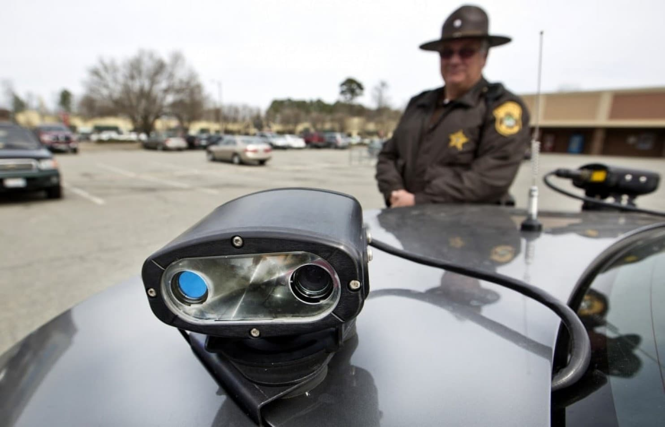
Augmented reality glasses will help the cops to trace the location of their colleagues by use of GPS. The functions of AR are similar to the smartphones’ locating truck features, but AR glasses has an added advantage of discovering the location of other police officers without using normal hands in operating the AR glasses. The policemen can see through the walls and building by use of AR 5G enabled. Seeing through the walls and structure helps the officers to locate their colleagues when that is injured and also finds the criminals hiding in buildings.
Fifth generation network with its high speed and significant data capacity help the police officers to conduct scour of the data collected by surveillance systems and spot anomalies. The police are always at on lookout for tips and intelligence on suspicious activities and potential threat. The law enforcement urgencies are not able to monitor and keep track of every person who may break the law due to limited personnel and the large population to be controlled. Significant data crime mapping is used by police officers to predict the areas that are likely to experience criminal activities. 5G network plays a significant role in enabling the law enforcers to trace people who are associated with cases of false threat s which at times disrupt the daily activities of innocent citizens.
Training academy among other controlled environments is much more flexible in their method of choosing the best equipment that needs to be deployed during the training. Students always like to deal things that are attractive to them, and they enjoy interacting with them. AR can be used to stimulate a dangerous police environment while at the same time blend the real-world equipment.
The critical components of effective policing activities in the rapidly changing world are the ability to deploy the new technology for maximum benefit. The AR is a result of a high-speed network that has high storage capacity and information within a very short time. Introduction of new devices always gives us an opportunity and ability to better what already exists to be more efficient and effective than in the past. It is true that old thinking and processes need to be abandoned completely and adopt the new technologies that usually come with innovations and opportunities in life. Yes, 4G was good can could not support AR, but with 5G it is possible to do great and especially when it comes to the matter of privacy.
The technology development in communication sectors which are made more effective by the fifth generation network will enable the police to use robotic applications like drones with installed facial glasses to perform their surveillance without the need of personnel. Many countries are adopting the use of a robot to patrol public areas to minimize threats (Erol-Kantarci & Sukhmani, 2018).
Augmented reality with the application of 5G will facilitate the interaction of law enforcers with the diverse population and detect the criminals and crimes that are in progress. Integration of chemical, biological and explosive sensors could immediately alert the police on any local contamination and also provide recommendations about the required measures to protect the public from the harm. This is made possible by the high technology and big data storage in the in AR systems.
Augmented reality will be in a position to interpret different languages and at the same moment recording the exact time. Fifth generation networks enable the AR to be able to read-time language in the same line with information on cultural behaviors which will strengthen the relationship between the police and the community and hence improve on the information flow (Erol-Kantarci & Sukhmani, 2018). The real-time intelligent about crime and criminal in the area of patrol will be displayed immediately by the AR calling for the constant patrol to curb the crime.
A well designed AR with high speed and significant storage capacity will enable the police officers to be able to access public transportation routes, building plans, and public utility information to improve the situational awareness and respond to problems that are likely to arise. The biometric recognition data such as facial and voice-print of unknown law breakers allows police officers to identify the wanted people through observing the citizens while they are in their daily activities and they are able to locate criminals. The police will be able to trace criminals even in their houses a situation that can only be done through 5G in AR.
Criminal investigators in law enforcement department are applying the current technology and information to perform their investigations. Augmented reality will help the investigators to improve information collection about the crime and arrest the criminals within a short time. AR will improve the interrogations through use of thermal imaging which will help to determine the truthfulness of the statements recorded by the suspects. Speaker recognition technology will be made real by the 5G in augmented reality, and it gives the investigators the ability to relate voices belonging to known criminals accurately. AR through the fifth generation network will lead to more developed advanced optics, which will make the investigators read and see from vast distances where listening is not applicable (Erol-Kantarci & Sukhmani, 2018).
5G will enhance response time making it very fast than one can imagine. The police departments will apply the augmented reality in management and supervisions. The leaders will be able to supervise all the activities in the firm and get responses within a very short time. Law enforcement has been having challenges on the supervising and managing their policemen’s’ data while they are in mobile missions. AR installed with the 5g network will enable them to monitor all the activities and get responses immediately. The management can monitor the whereabouts, activities and the status information given in a three-dimensional map display. By using video feed from their personnel on the streets, the administration can see what their people are doing in real-time one on one.
The increased speed and large data storage in the current technology that is facilitated by the 5G network enables the police management and the supervisor to monitor the physiological status of all their personnel help them to allocate duties based on who is mentally and physically suited. The coordination of different units in law enforcement can be strengthened by the use of visual, audio and haptic cues from the management in the central office. Police need to have a device that will help them to investigate the crime scene.
The new developed 5G internet will enable the police to apply trace app. The invention will be having few pairs of goggles available while walking through the crime scene will help to store all the details in its storage because the place is scanned and digitally preserved. Trace app enables the investigators to interpret the objects orally and put in the record of all things they see in by wearing the AR glasses. The evidence remains in virtual space along with the annotations left by the officers.
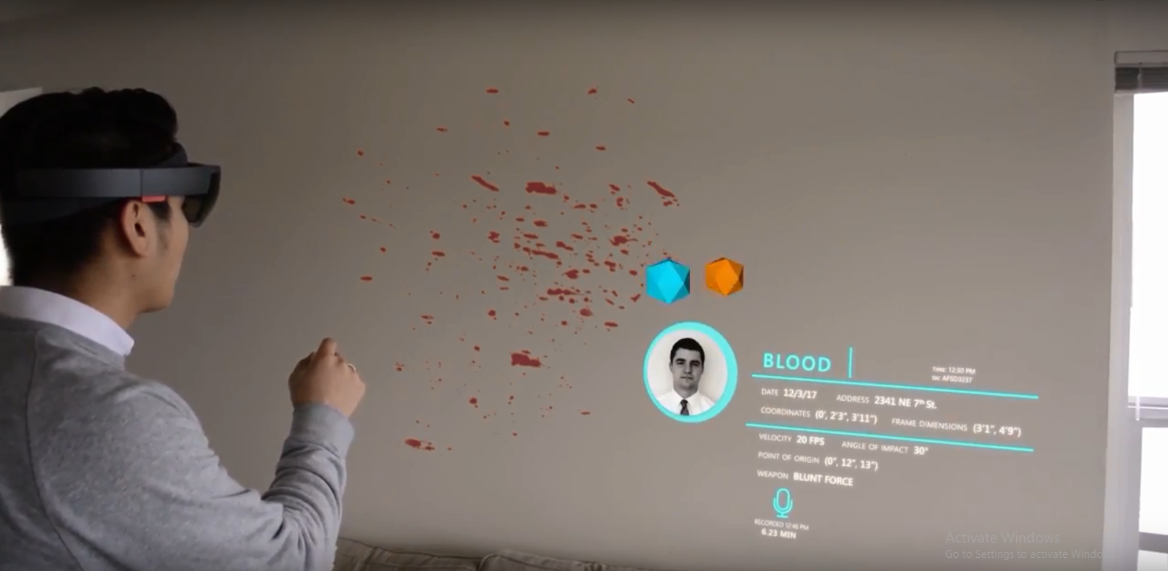
Augmented reality gives the world numerous opportunities and police as well. As the level of technological system raises, the level of knowledge, education, and training required to oversight and control also increase. Educated and well-trained personnel in the police department are needed to be to run the augmented reality so that can meet the desired goals against criminals and terrorists in the society. Terrorists also deploy the use of high technology in their daily crime operations. Some terrorists have even high technology gadgets than the police. The police need not only to come up with the required knowledge but also visions and imaginations on how the terrorists can be using the experience against society.
The ability of AR to integrate a large amount of particular database information into a policemen’s field of view, without interfering with the current activities is of more advantage for situational awareness and the officer’s safety. The augmented reality enables the information processing and decision-making occur almost at once or one after the other in a real-time. With the new technology with broad and wireless networks, intelligent environments in collaboration with newly developed sensors, the information that will be available for the individual cop will be unprecedented. AR will make it possible for the policemen to directly access use useful information concerning a given environmental landscape and its occupants will play a significant role in fighting crime and enhancing public safety.
Augmented reality makes it possible to display real and virtual in real-time for an individual operating in a given environment enabling the policemen to accomplish specific tasks and missions. The augmented reality brings varieties of technologies together and can supply the required information to different departments in the enforcement unit. AR came to help the situations that cannot be detected by human senses. The cops usually block some aspect of the real world may hinder the accomplishment of the desired objectives by the law enforcers by the use of AR which uses 5G network.
The police officers need to maintain a connection among them. According to Huawei, 5G network can provide millions of connections per square kilometer that is needed by the AR to be to operate. AR technology is able to connect with many devices and hence providing the required information without caring the number of people with that geographical area. The law enforcement requires the million and billions connections to be able to accomplish its objectives within a given time, something that 4G cannot.
The police are always at on lookout for tips and intelligence on suspicious activities and potential threat. The law enforcement urgencies are not able to monitor and keep track of every person who may break the law due to limited personnel and the large population to be controlled. Significant data crime mapping is used by police officers to predict the areas that are likely to experience criminal activities.
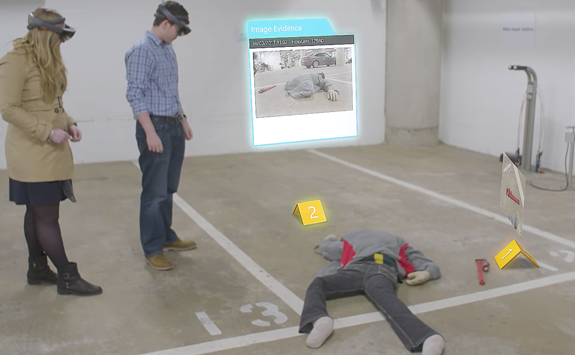
Augmented reality makes it make it possible for the police to get information at the very best, right time and with the best methodology. Police officer requires correct information so that they can make a wise and cordial decision. With the use of AR, it is not possible to obtain information directly from people because of biases (Daniels, 2018). The fifth the devices used deals with reality. The data recorded by the AR is the original information and there when making the ruling, it is always free and fair. The judges use the information when making their rules in the court while the people involved are given time to see and listen to the witness before the rulings are done. The ability of augmented reality to create crime scene is among the achievement of 5G network as the police are able to retrieve all the activities done on the crime scene. It is very true that AR really adds a lot of values to the policing unit.
AR is intended to provide a wide range of application in law enforcement departments. The new 5-G network enabled AR in law enforcement department faces some challenges which include limited knowledge and creativity among the police officers.
Inclusion, law enforcement has a lot of things that can benefit from augmented reality. The AR in law enforcement offers many benefits from its incredible features. The cameras attached to the glasses, the officer can record videos of the crime on time of happening. The AR helps the jury to understand the exactly what happened and make better decisions in responding to the information received. Augmented reality gives the police investigating department time to analyze the entire incident following step by step (Sundaresan, 2018). The law enforcement aims at investing less and in return get the best device that suits their daily activities. The government will spend on glasses which will help the workers to make credible advantages and plan case study accordingly.
The one-time investment will enable the police to stand at a better position to handle criminals. AR glasses offer some added advantage to perform the duties without using the hand, a situation that could be demanding since there is a risk of gangers or crime that is happening at every given time. Augmented reality also plays a significant role during the training session making the teaching more exciting and knowledgeable. Via AR, the officers are trained under realistic three dimension environment, which usually helps them to perform better in time of duty.

References
Daniels, D. B. (2018). Cybersecurity Implications in Mobile Device Augmented Reality Applications. GSTF Journal on Computing (JoC), 4(1).
Erol-Kantarci, M., & Sukhmani, S. (2018). Caching and Computing at the Edge for Mobile Augmented Reality and Virtual Reality (AR/VR) in 5G. In Ad Hoc Networks (pp. 169-177). Springer, Cham.
Lemley, M. A., & Volokh, E. (2017). Law, virtual reality, and augmented reality. U. Pa. L. Rev., 166, 1051.
Orlosky, J., Kiyokawa, K., & Takemura, H. (2017). Virtual and augmented reality on the 5G highway. Journal of Information Processing, 25, 133-141.
Sundaresan, K. (2018, October). 5G: An Evolution Towards a Revolution. In Proceedings of the 24th Annual International Conference on Mobile Computing and Networking (pp. 659-659). ACM.

